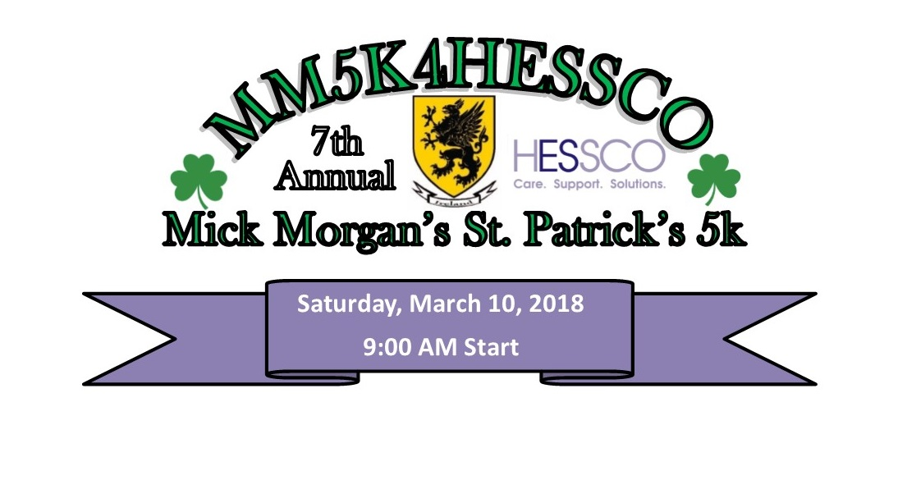
January 1, 2018

Dear Friend,
This is an exciting year for HESSCO and its Annual Mick Morgan’s St. Patrick’s 5K. Year number seven! As such, we are looking for your help to really make an impact and reach our goal of raising over $50,000. A beautiful race route, fun venue, awesome long sleeve tech T-shirts and a spirited St. Patrick's Day celebration are just some of the reasons this race has become so popular…OUR favorite reason is that all proceeds from this race go directly to support HESSCO programs and services!

Our Annual 5K coincides with the national March for Meals Campaign which mobilizes hundreds of local Meals on Wheels programs across the country to reach out to their communities and build support – a perfect opportunity for us to shed light on HESSCO’s Nutrition Program. With the assistance of an impressive 835 volunteers (made up of individuals and groups who “adopt” routes), HESSCO packages and delivers an average of 130,000 home delivered meals each year and serves an additional 30,000 meals annually in dining room settings. Our drivers not only deliver a hot, nutritious meal, but they provide a wellness check and a friendly visit. For many, this is the difference needed to maintain their dignity and independence at home.

By sponsoring the 7th Annual St. Patrick’s 5K for HESSCO, you will not only be promoting your company/agency, but you can feel good knowing that you are rallying around this great cause and helping HESSCO to continue our mission of delivering meals to those who have difficulty making their own, providing homemaking and home health aide services to those in need, advocating for residents in nursing facilities, counseling Medicare recipients on health insurance options and protecting our seniors from neglect and abuse.

Please consider supporting HESSCO by sponsoring the 5K this year. The Sponsorship Opportunities are attached. If you require additional information, please feel free to call me at 781-784-4944 extension 251 or email me at dfradkin@hessco.org. Thank you in advance for your support. Together, we can make a difference!
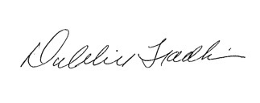
Sincerely,

Debbie Fradkin, Community Relations Manager, HESSCO

HESSCO is a qualified 501C3 non-profit organization and is registered in good standing with the Commonwealth of Massachusetts as a public charity.

